INTRODUCTION: https://whowaswhowari.sdsu.edu/WWW4INTRO.docx
BIBLIOGRAPHY: https://whowaswhowari.sdsu.edu/WWW4BIBLIO.docx
ABBREVIATIONS: https://whowaswhowari.sdsu.edu/WWW4ABBREV.docx
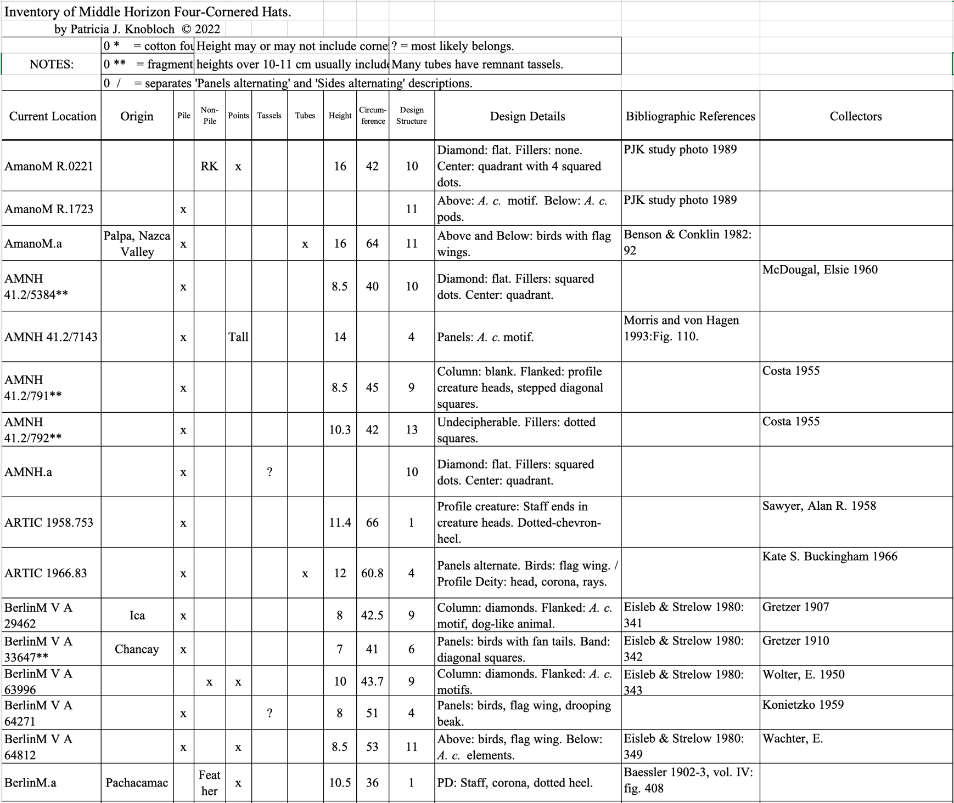
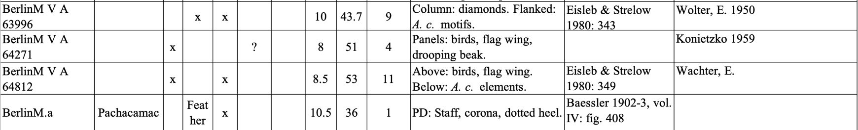
AmanoM AMANO, Museo Textil Precolombino
http://www.museoamano.org/ (study photo)
AMNH American Museum of Natural History
https://anthro.amnh.org/collections
ARTIC Art Institute of Chicago
https://www.artic.edu/collection
BerlinM Staatliche Museen zu Berlin
https://recherche.smb.museum (museum site; study photos)

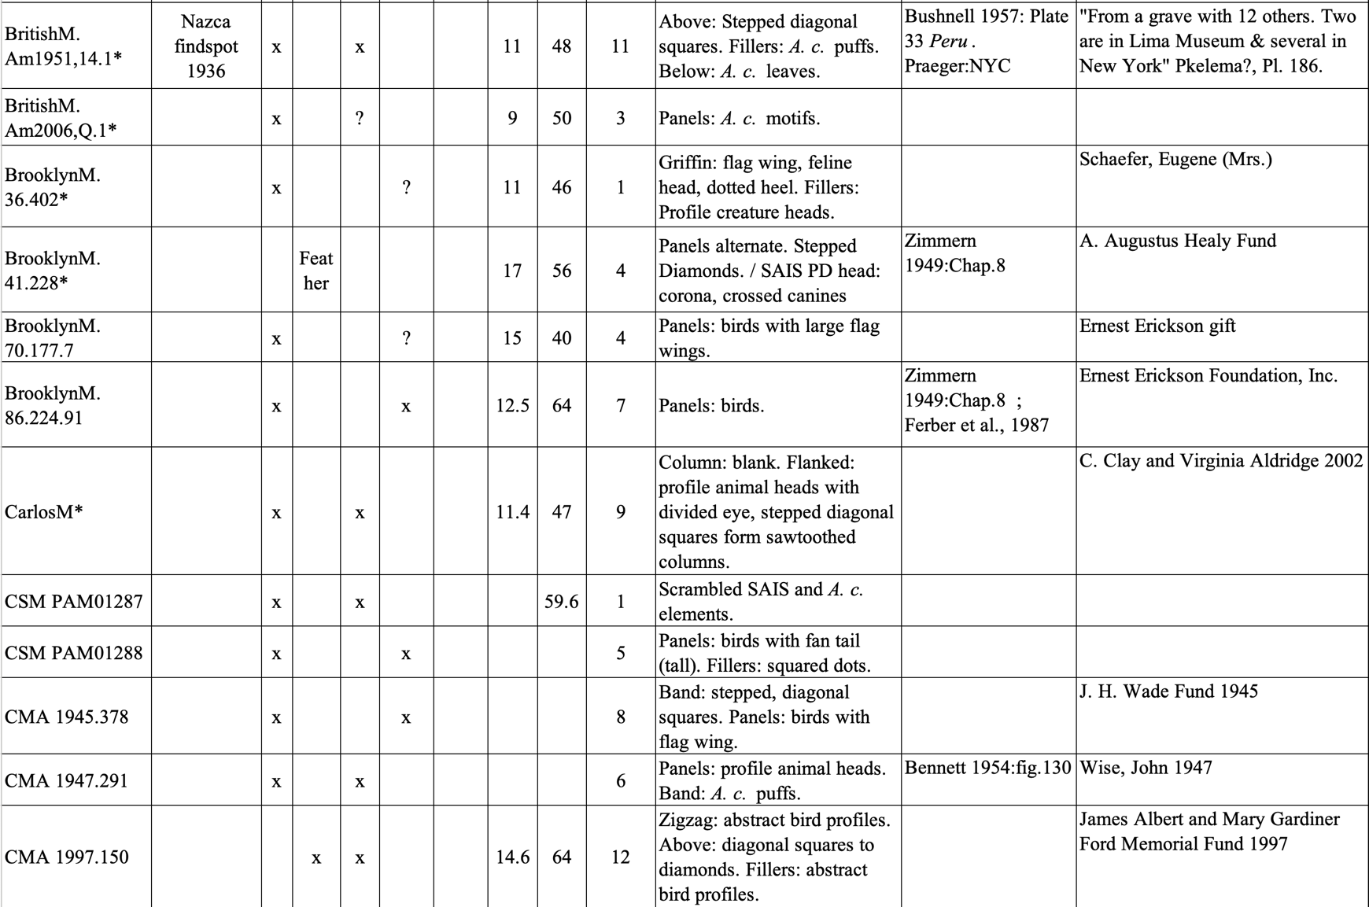BritishM British Museum

https://www.britishmuseum.org/collection

BrooklynM Brooklyn Museum

https://www.brooklynmuseum.org

CarlosM Michael C. Carlos Museum, Emory University

https://collections.carlos.emory.edu

CSM Castello Sforzescol, Milan

Wikimedia: https://commons.wikimedia.org/wiki/File:Raccolte_Extraeuropee_-_PAM01288_-_Per%C3%B9_-_Cultura_Huari.jpg

Wikimedia: https://commons.wikimedia.org/wiki/File:Raccolte_Extraeuropee_-_PAM01287_-_Per%C3%B9_-_Cultura_Huari.jpg

CMA Cleveland Museum of Art

https://www.clevelandart.org/art/collection/search

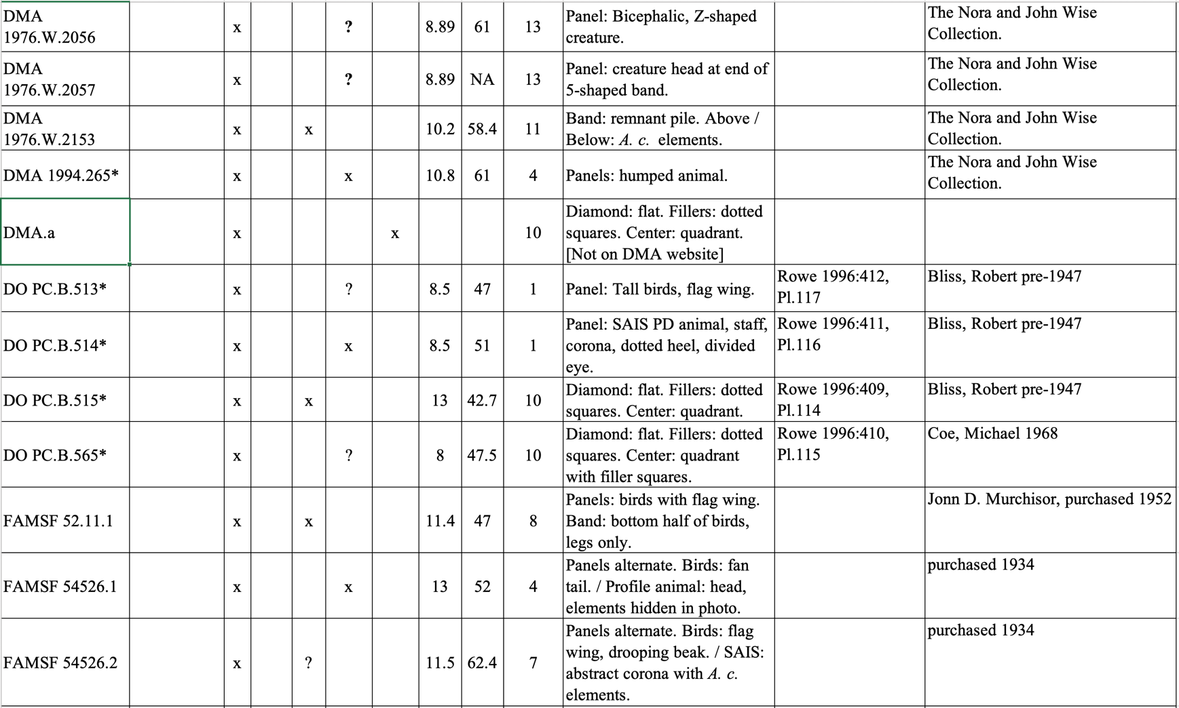

DMA Dallas Museum of Art

https://collections.dma.org

DAM Denver Art Museum

https://www.denverartmuseum.org

DO Dumbarton Oaks

https://www.doaks.org/resources/online-collections

FAMSF Fine Arts Museum of San Francisco

https://art.famsf.org

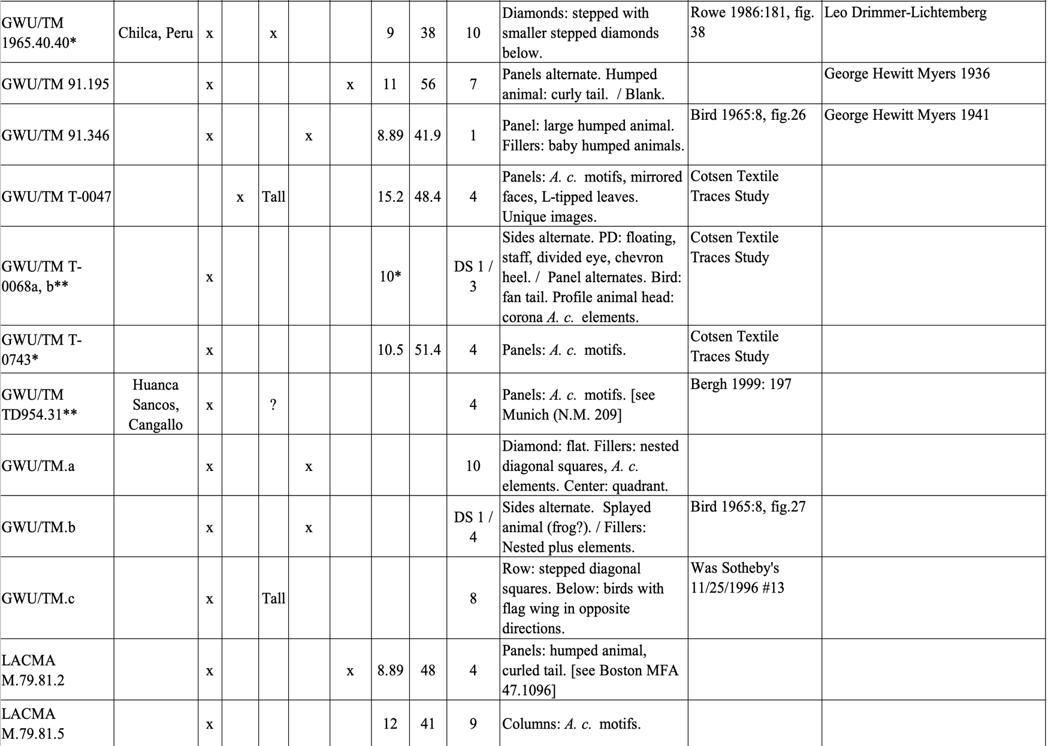

GWU/TM Textile Museum

https://museum.gwu.edu/indigenous-american-textiles

LACMA Los Angeles County Museum of Art

https://collections.lacma.org

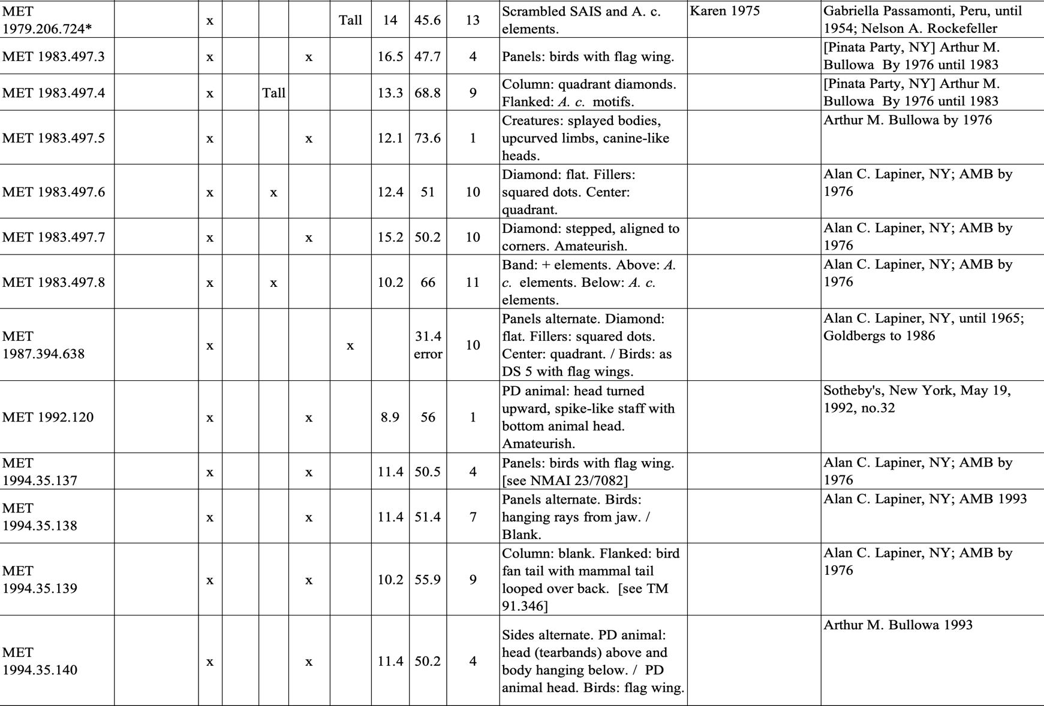
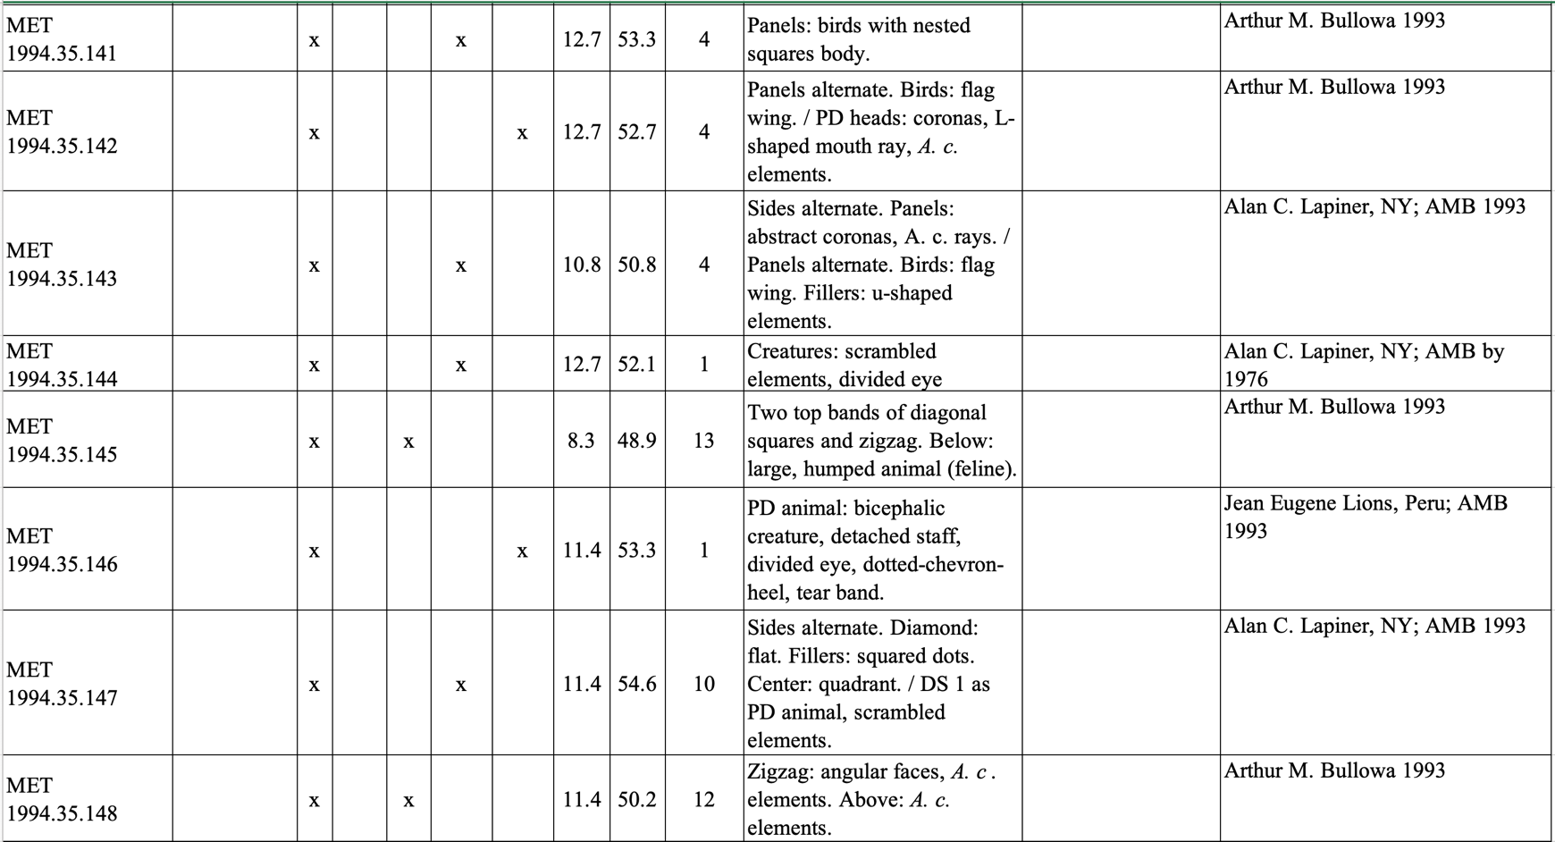

MET Metropolitan Museum of Art https://www.metmuseum.org

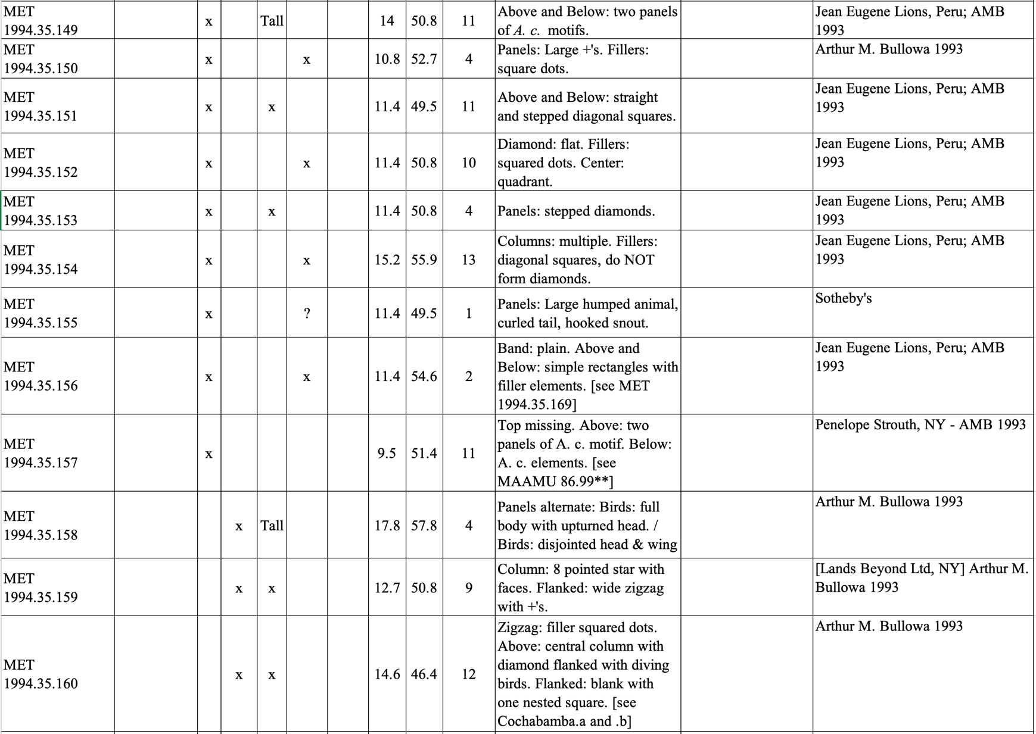
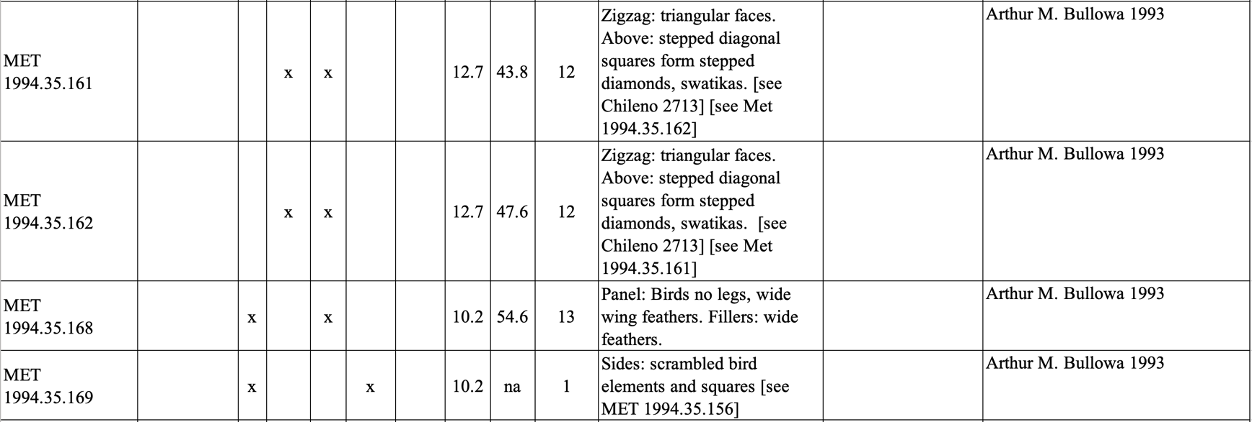

MET Metropolitan Museum of Art
https://www.metmuseum.org

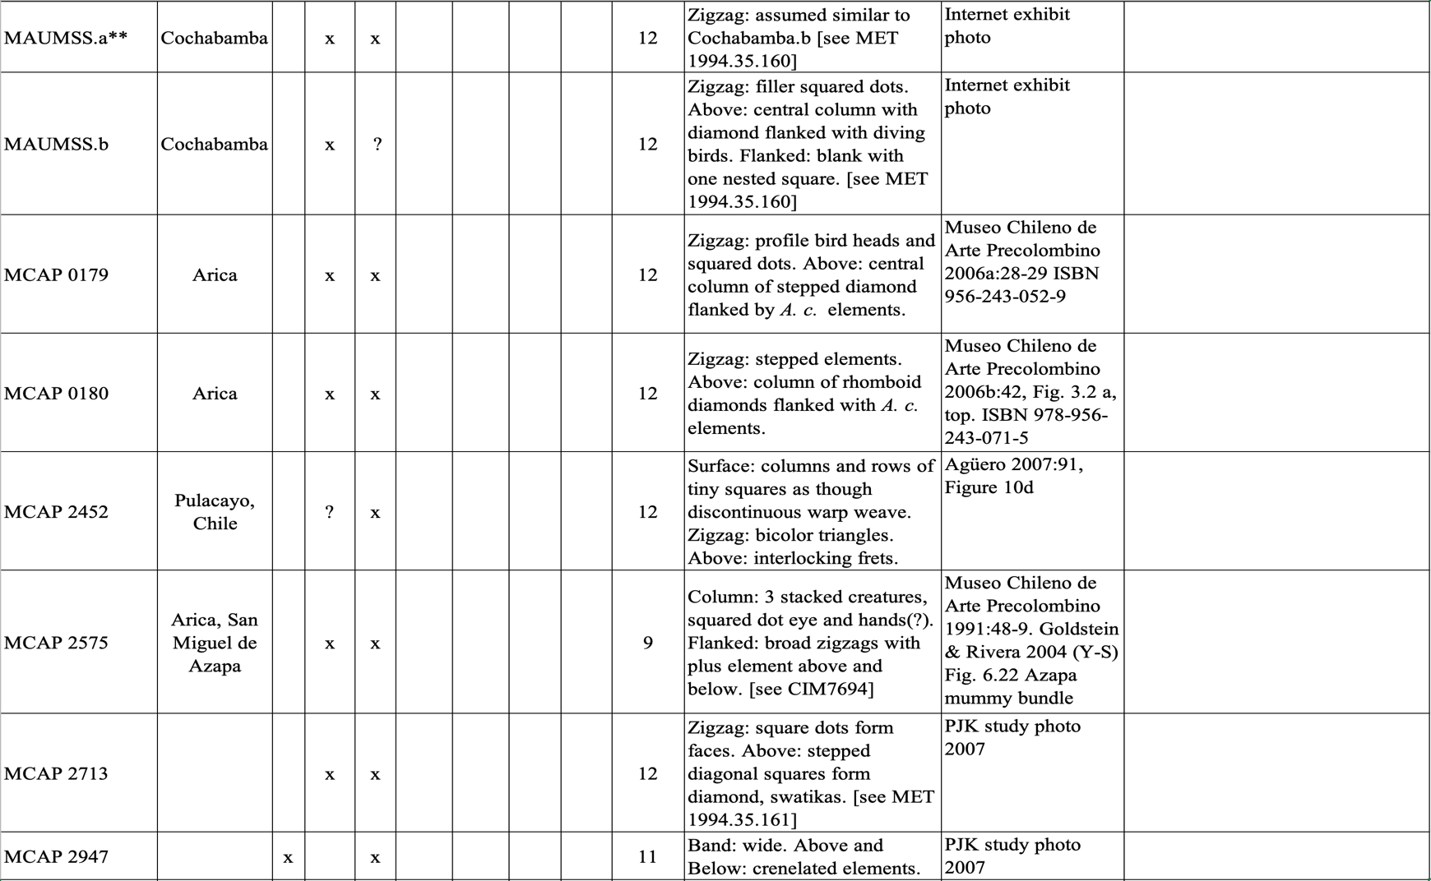
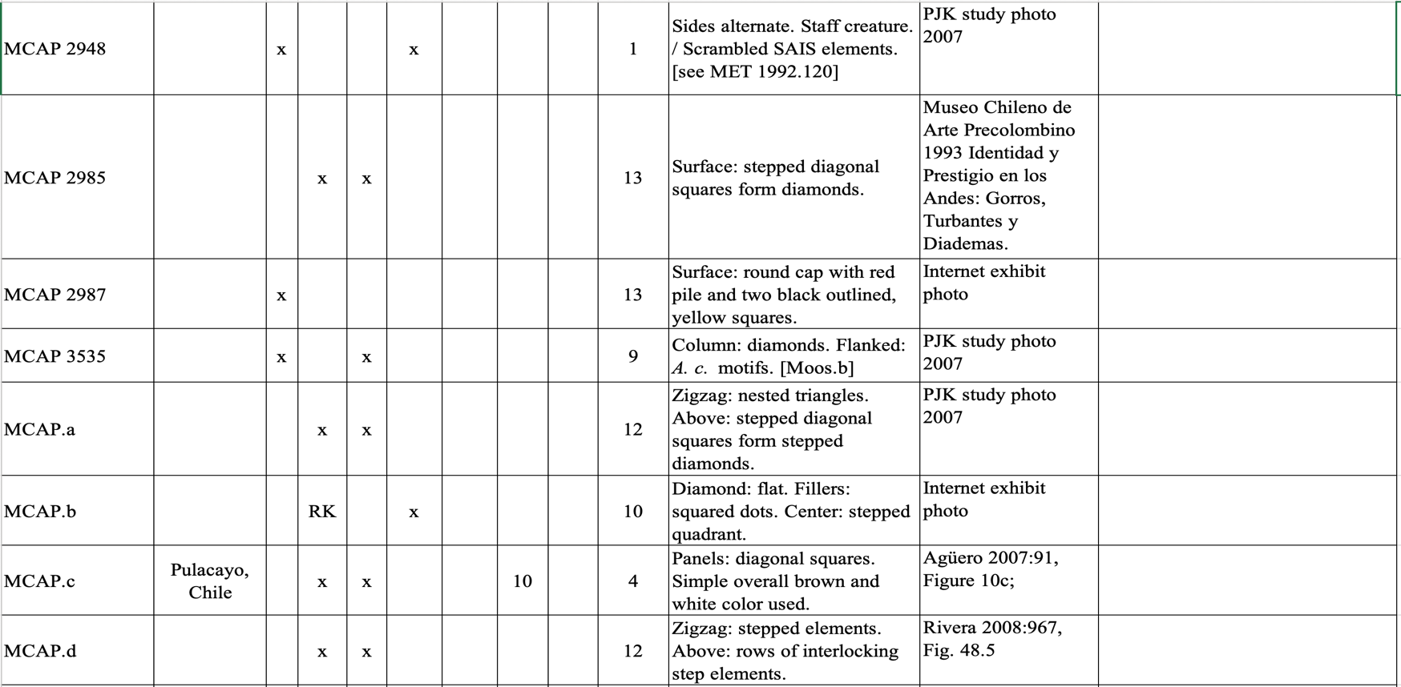MAUMSS Museo Arqueológico de la Universidad Mayor de San Simón, Cochabamba

https://museo.umss.edu.bo (website photo)(may have been a third hat).

MCAP Museo Chileno de Arte Precolombino

https://museo.precolombino.cl/el-lenguaje-de-los-objetos (bibliography)(study photos)

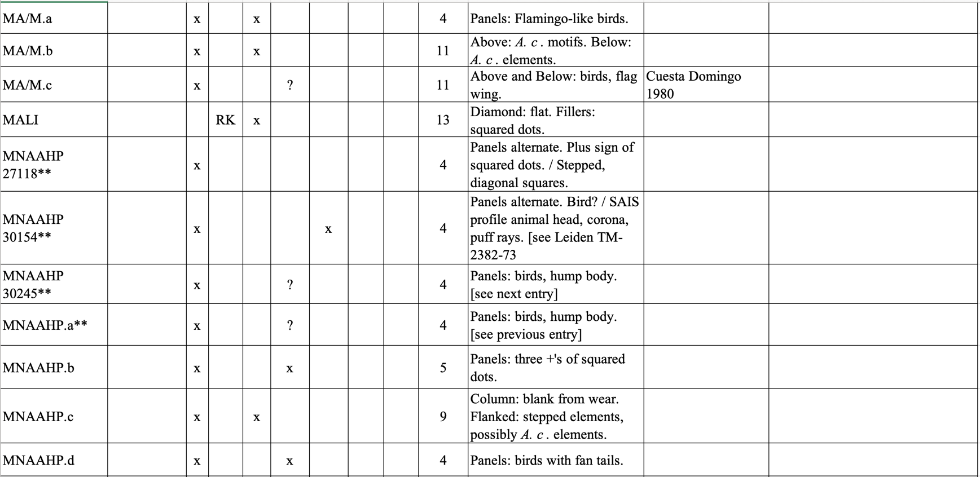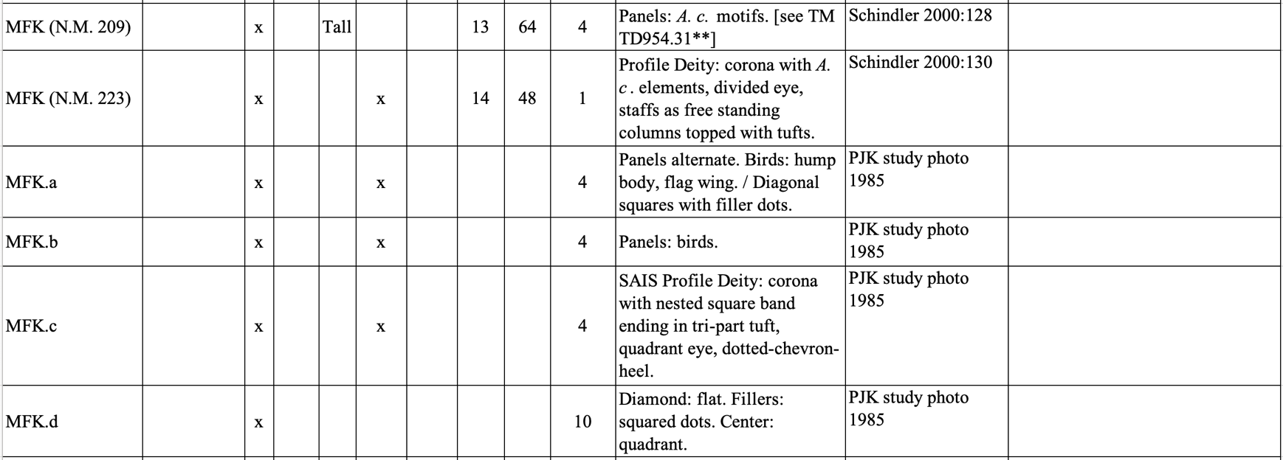

MA/M Museo de América, Madrid
https://www.culturaydeporte.gob.es/museodeamerica/coleccion/acceso-a-catalogo.html (extremely difficult search engine) (internet photos)

MALI Museo de Arte de Lima
https://mali.pe/coleccion (access problem)(internet photo)

MNAAHP Museo Nacional de Arqueología, Antropología e Historia del Perú https://mnaahp.cultura.pe/colecciones (online access not available at present, since 2002)

MFK Museum Fünf Kontinente, Munich
https://www.museum-fuenf-kontinente.de/services/english-summary.html (see Shindler 2000:128, 130) (study photos).

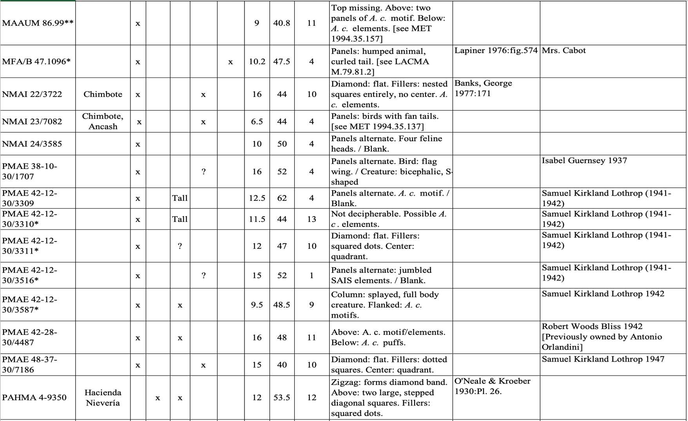
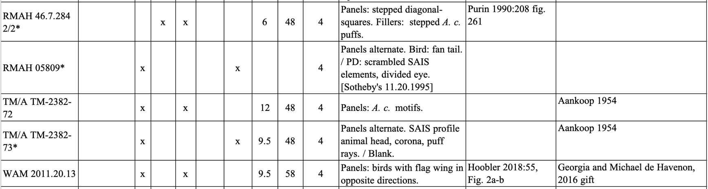
MAAUM Museum of Art and Architecture, University of Missouri
http://maacollections.missouri.edu/ArgusNET/Portal.aspx
MFA/B Museum of Fine Arts, Boston
https://collections.mfa.org/search/objects/*/47.1096
NMAI National Museum of the American Indian
https://americanindian.si.edu/explore/collections/search
PMAE Peabody Museum of Archaeology & Ethnology, Harvard University
https://peabody.harvard.edu/collections-and-research
PAHMA Phoebe A Hearst Museum of Anthropology
https://portal.hearstmuseum.berkeley.edu
RMAH Royal Museums of Art and History
https://www.carmentis.be/eMP/eMuseumPlus
TM/A Tropenmuseum, Amsterdam (Museum of the Tropics)
https://collectie.wereldculturen.nl
WAM Walters Art Museum
https://art.thewalters.org/detail/85463

AUTHORED RESOURCES:

Refer to BIBLIOGRAPHY - https://whowaswhowari.sdsu.edu/WWW4BIBLIO.docx

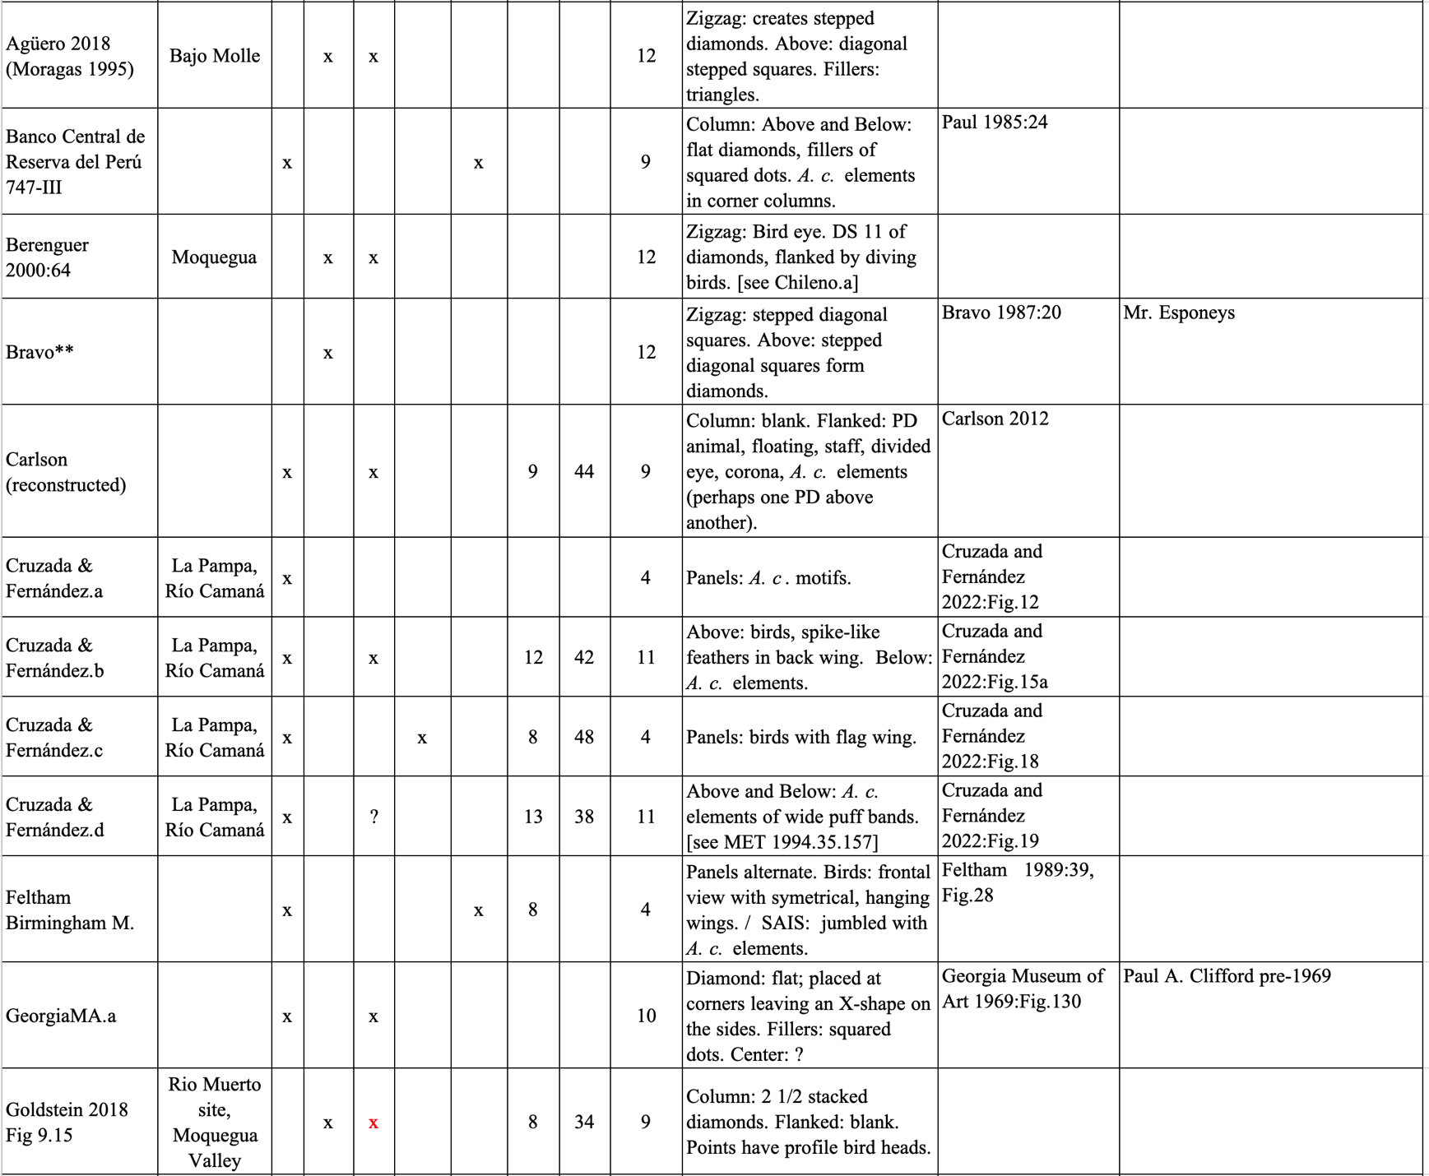
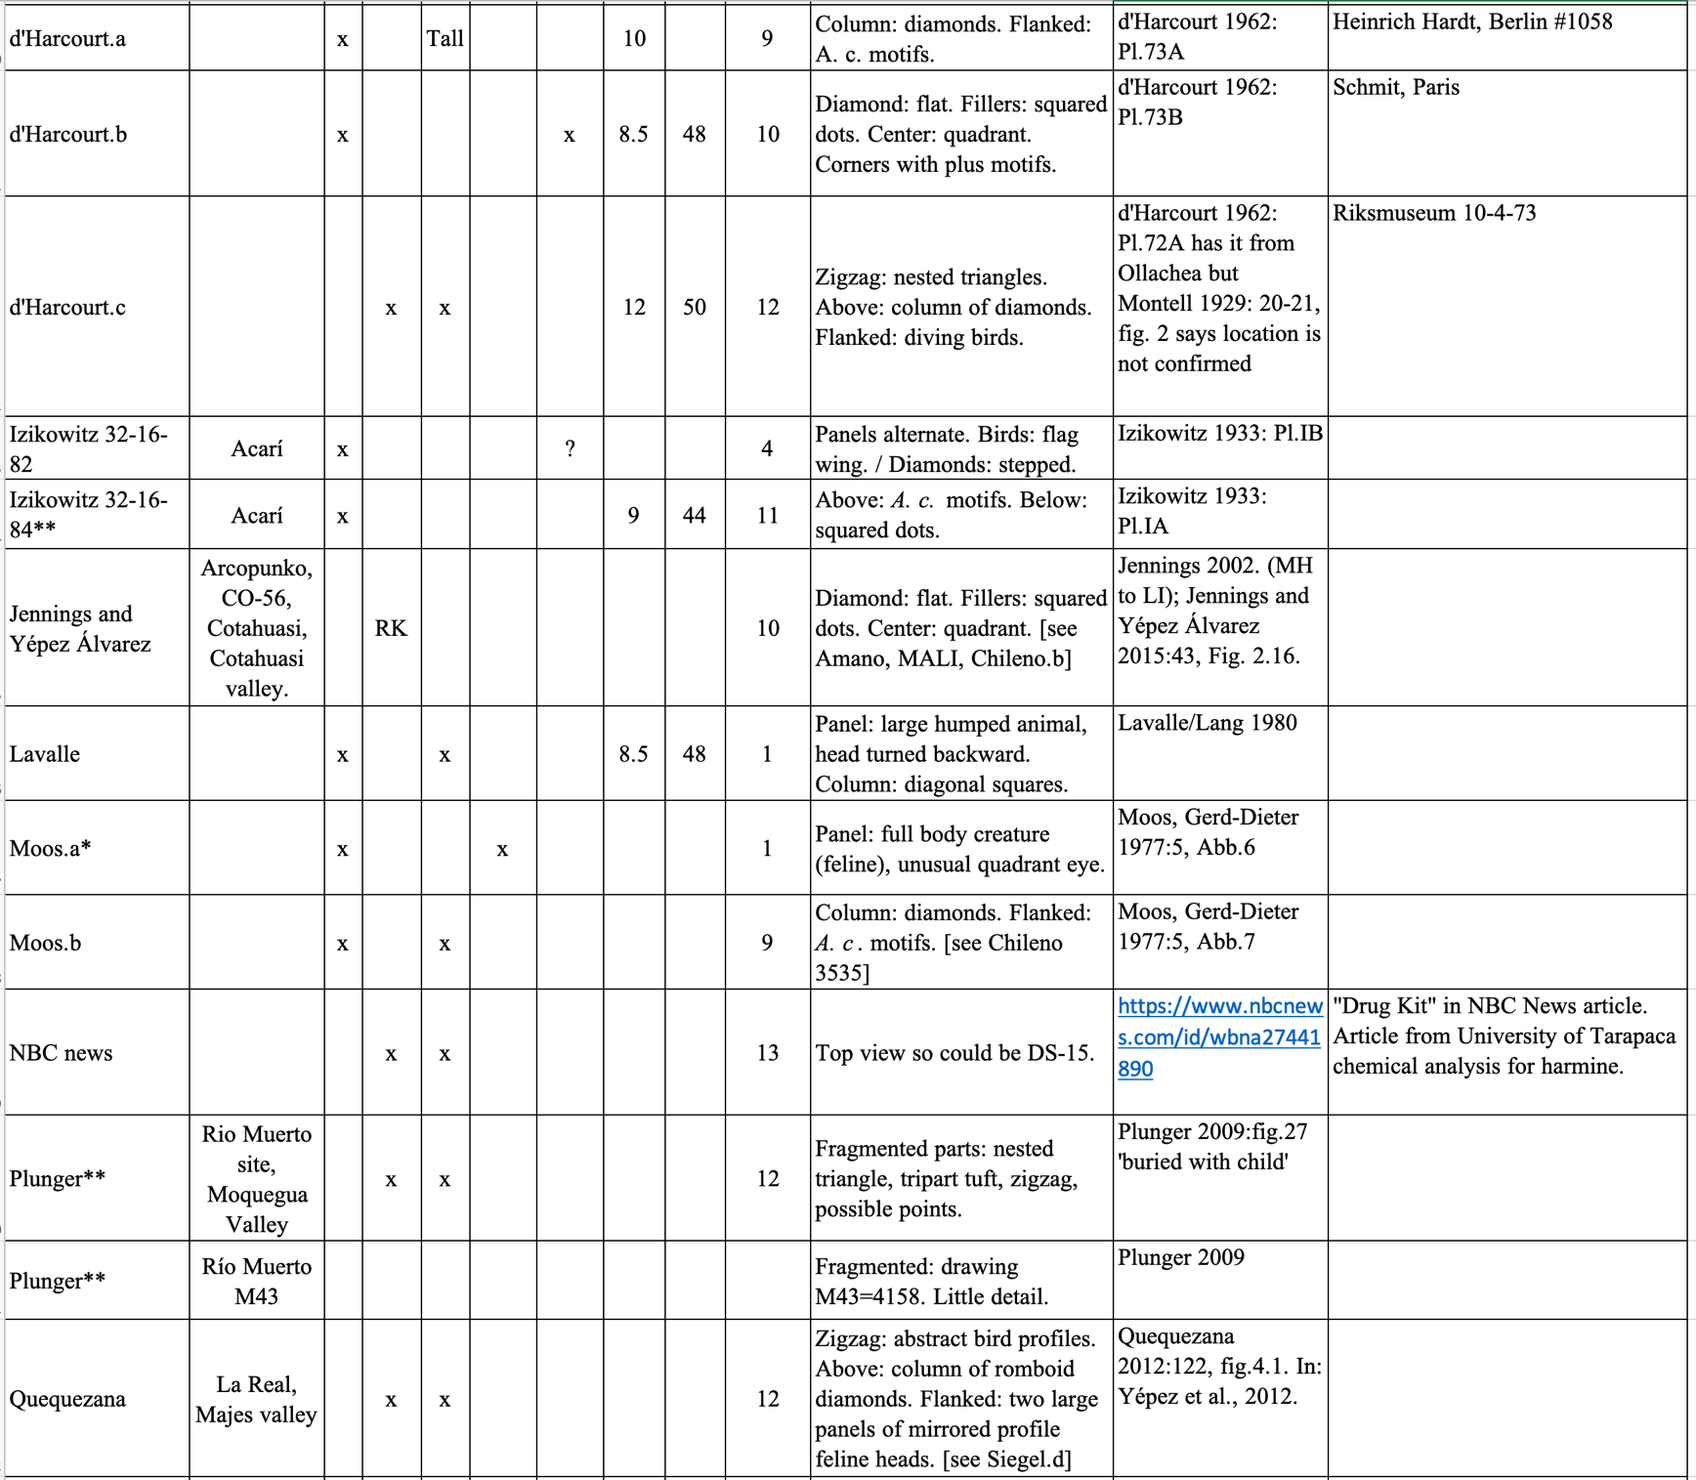
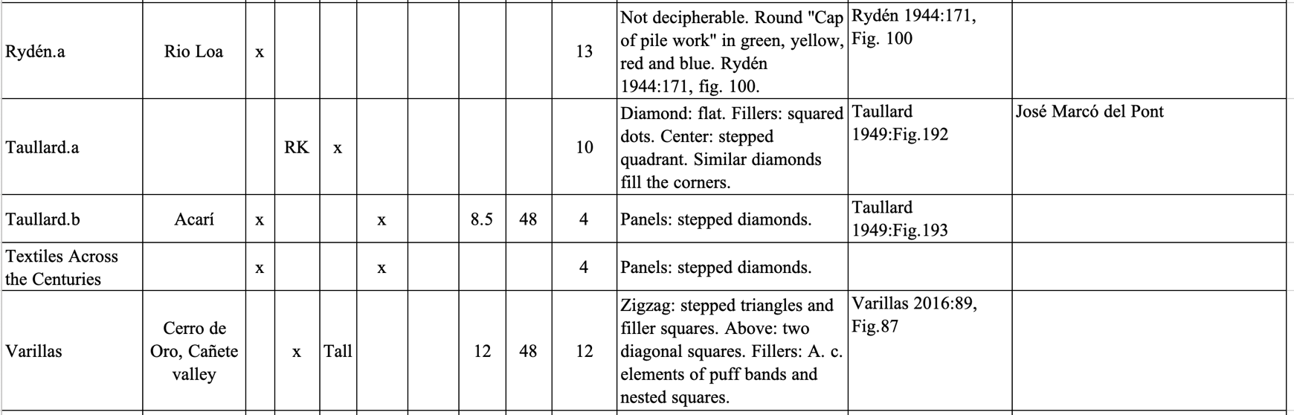

AUCTION – GALLERIES - PRIVATE COLLECTIONS

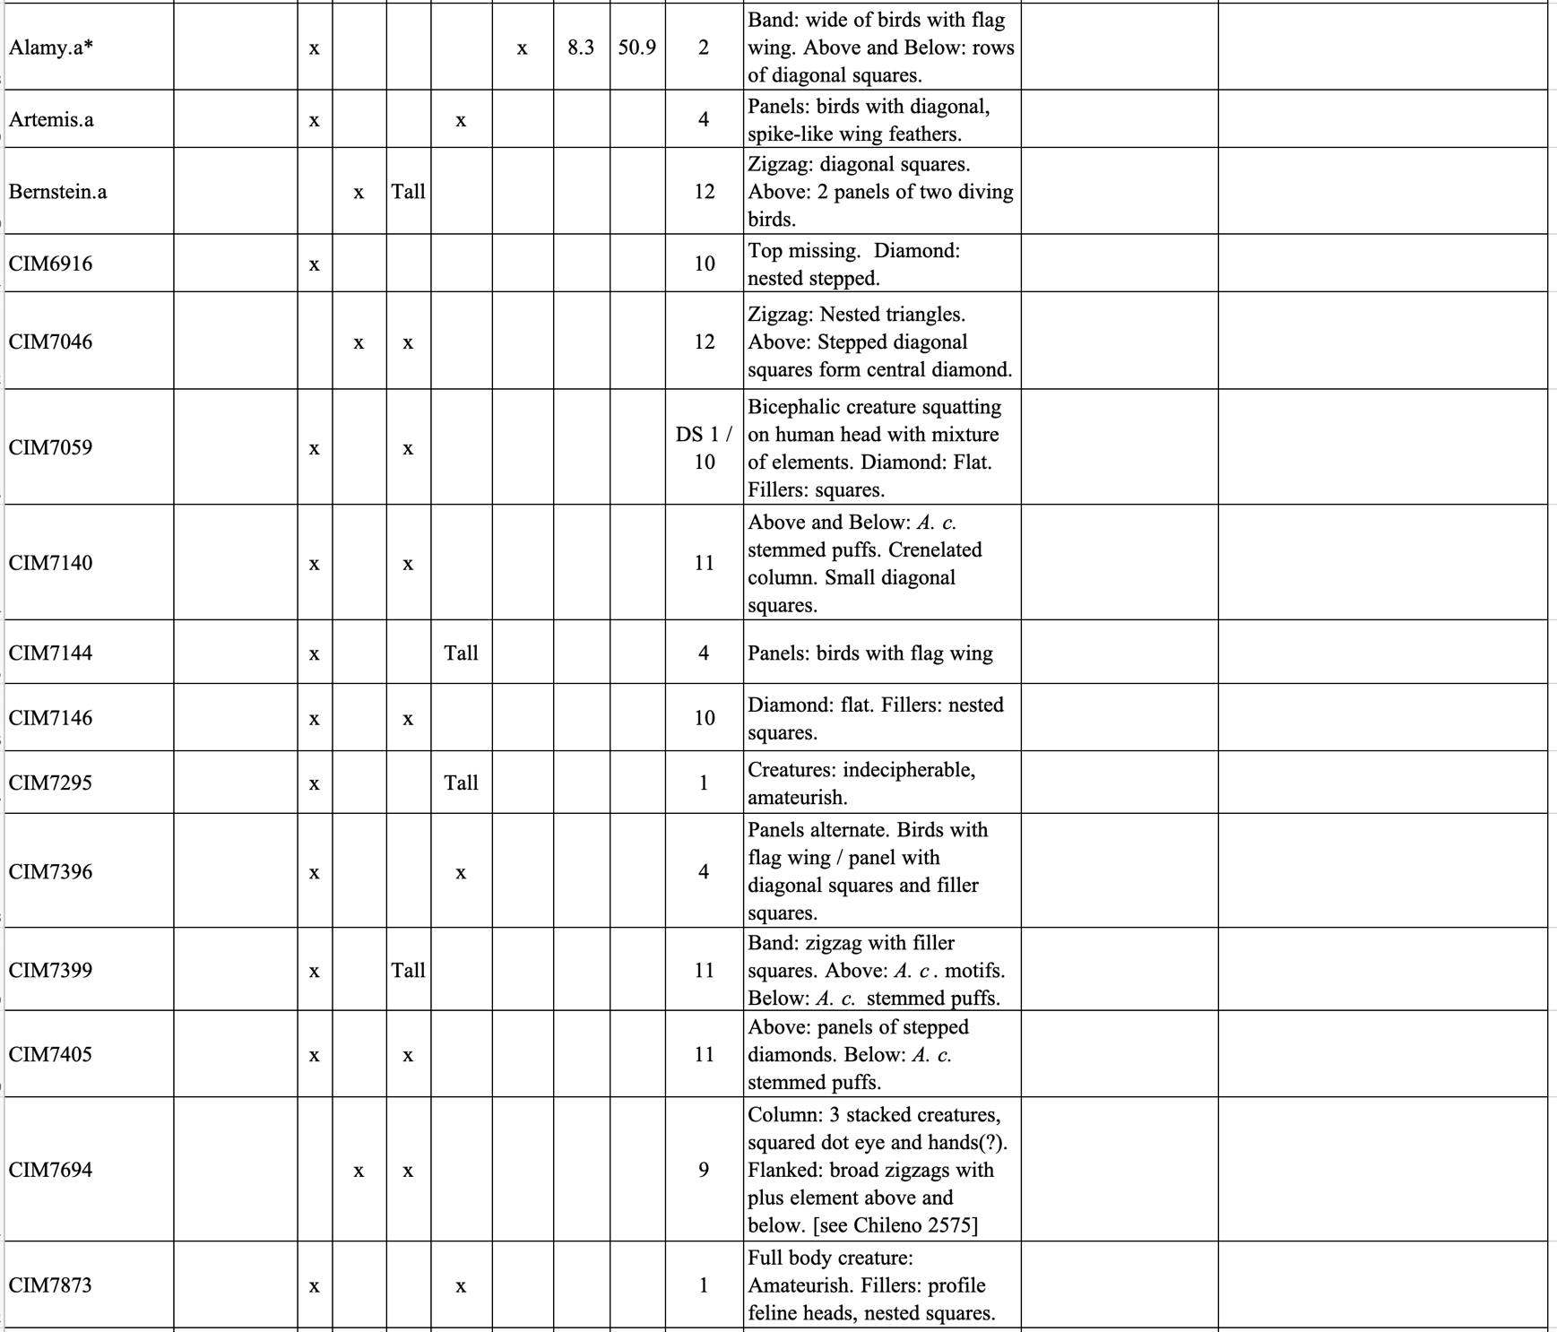

Alamy Inc., 49 Flatbush Ave., 130, Brooklyn, NY 11217 (Stock photos)
https://www.alamy.com/

Arte Primitivo, Howard S. Rose Gallery, 3 E 65th St #2, New York, NY 10065
https://arteprimitivo.com/

David Bernstein Pre-Columbian Art 355 E 72nd St 16 E, New York, NY 10021
https://www.precolumbianart4sale.com

CIM Private

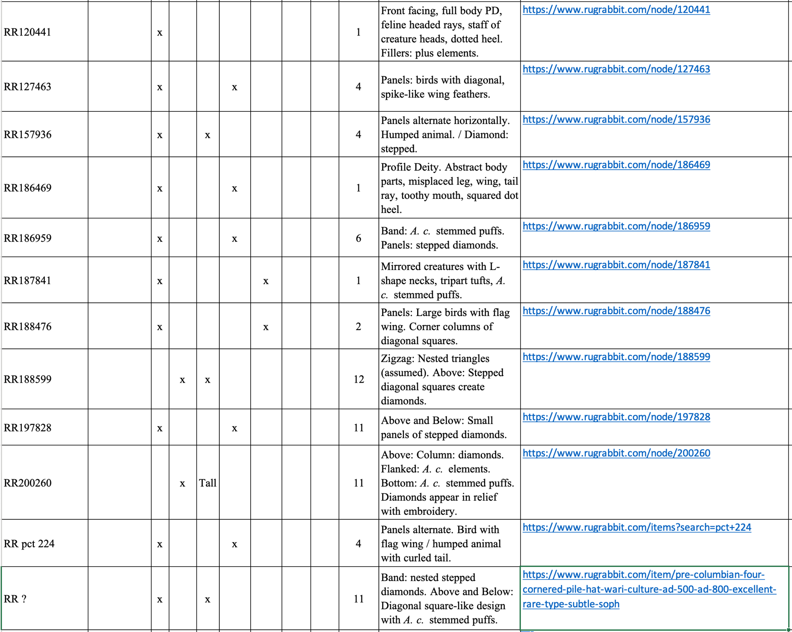

Rugrabbit James Blackmon Textile Art
https://www.rugrabbit.com/profile/440

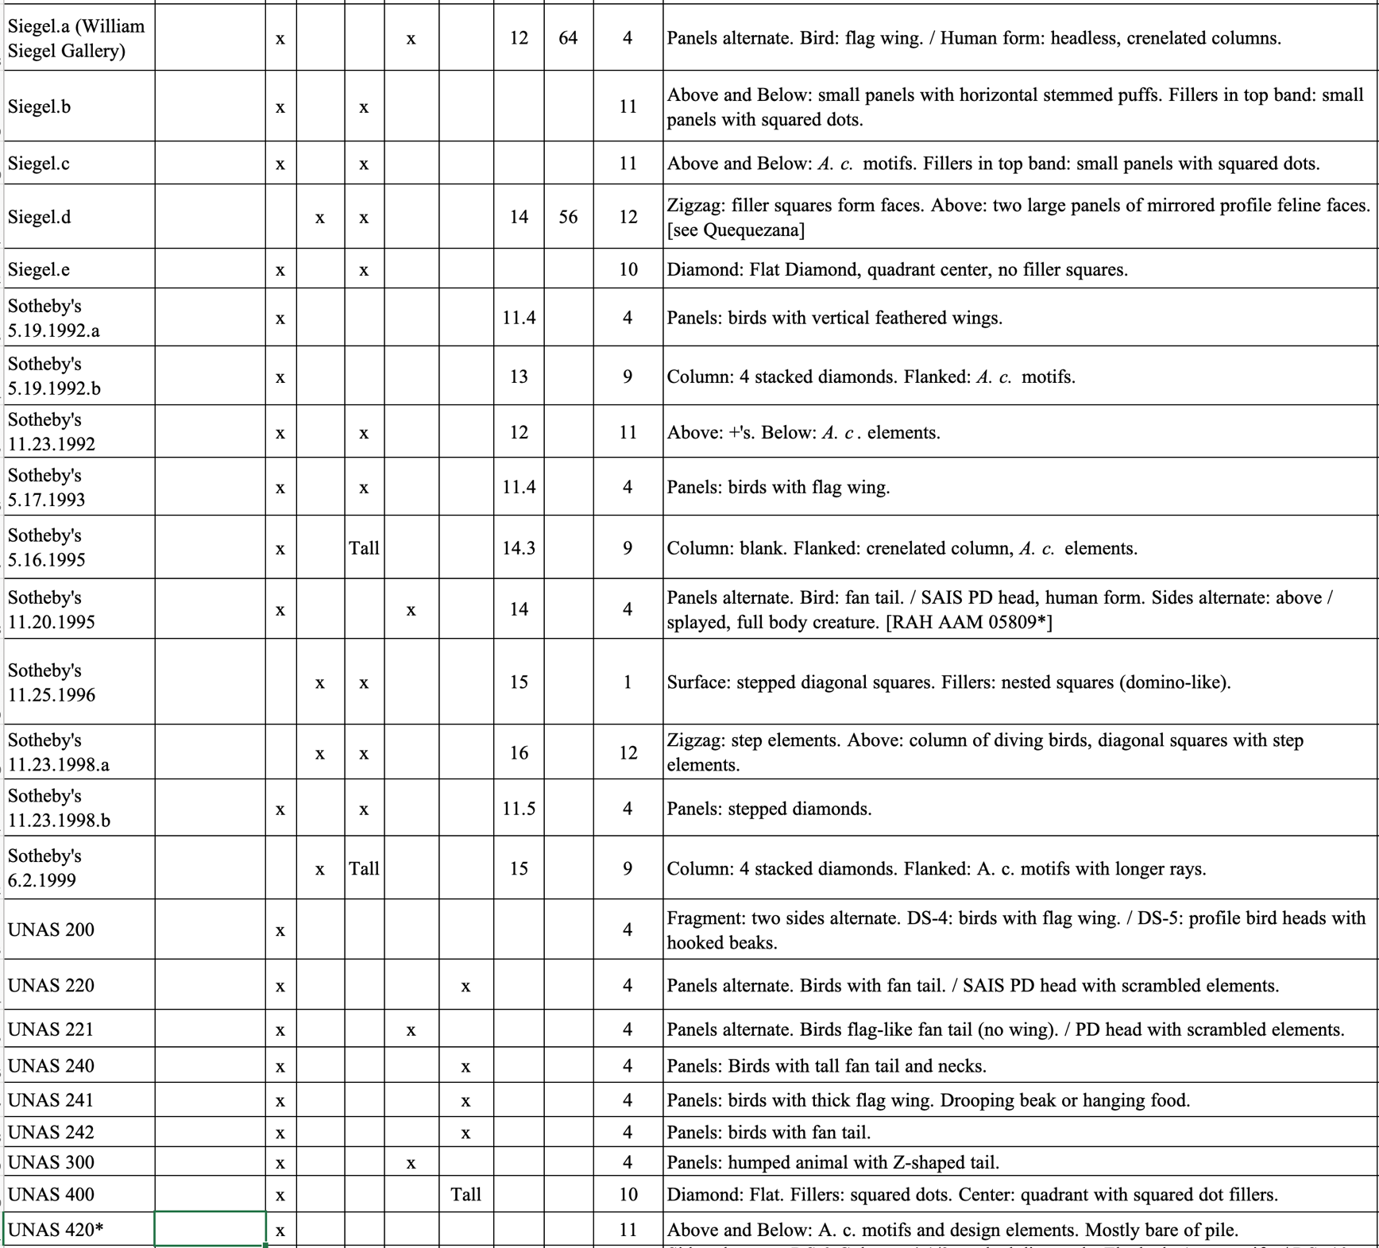
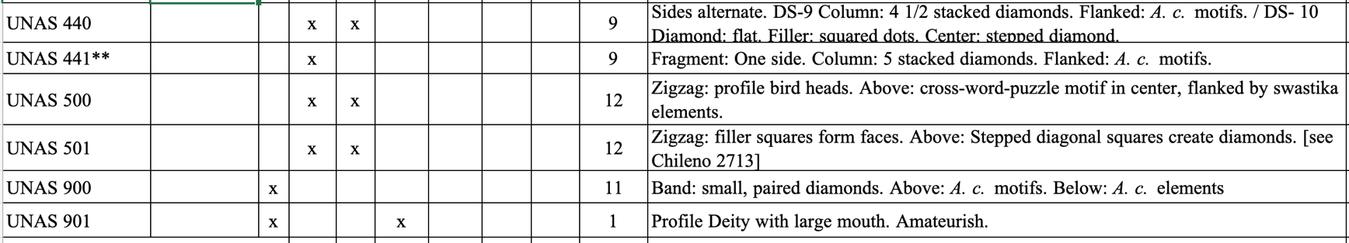

Siegel William Siegal Gallery, 130 E Marcy St, Santa Fe, NM 87501
https://williamsiegal.com/

Sotheby’s Founded: London, UK, March 11, 1744. Headquarters: NYC
https://www.sothebys.com/en/departments/pre-columbian-art?locale=en

UNAS UNASsigned (mostly Pinterest sources that are unknown)

Refer to BIBLIOGRAPHY - https://whowaswhowari.sdsu.edu/WWW4BIBLIO.docx

